RCN Ghana website
  - CMS Content Entry Guide

Contents
Introduction 3
Users 4
Administrators 4
Logging in 4
Adding new ‘users’ 4
Blocking users 6
Finding and adding content 7
Find content 7
Filter content 7
Add content 7
Add Article 8
Formatting advice 10
Images 11
Children 12
Publishing options 12
Embedding video or presentation 13
Add File 13
Add Biblio 14
Add Folder 14
Add Event 14
Add a Slide 14

Introduction
In 2017 the RCN Ghana website (www.washghana.net) has been renewed and existing content has been migrated to a new Content Management System (CMS).
This guide takes the user through the creation of common items on the new RCN Ghana CMS.

Users

Administrators
Currently the following persons have access to the website and have been assigned the role as administrators. They can create new content and can give new users access so that they can contribute to the content creation.
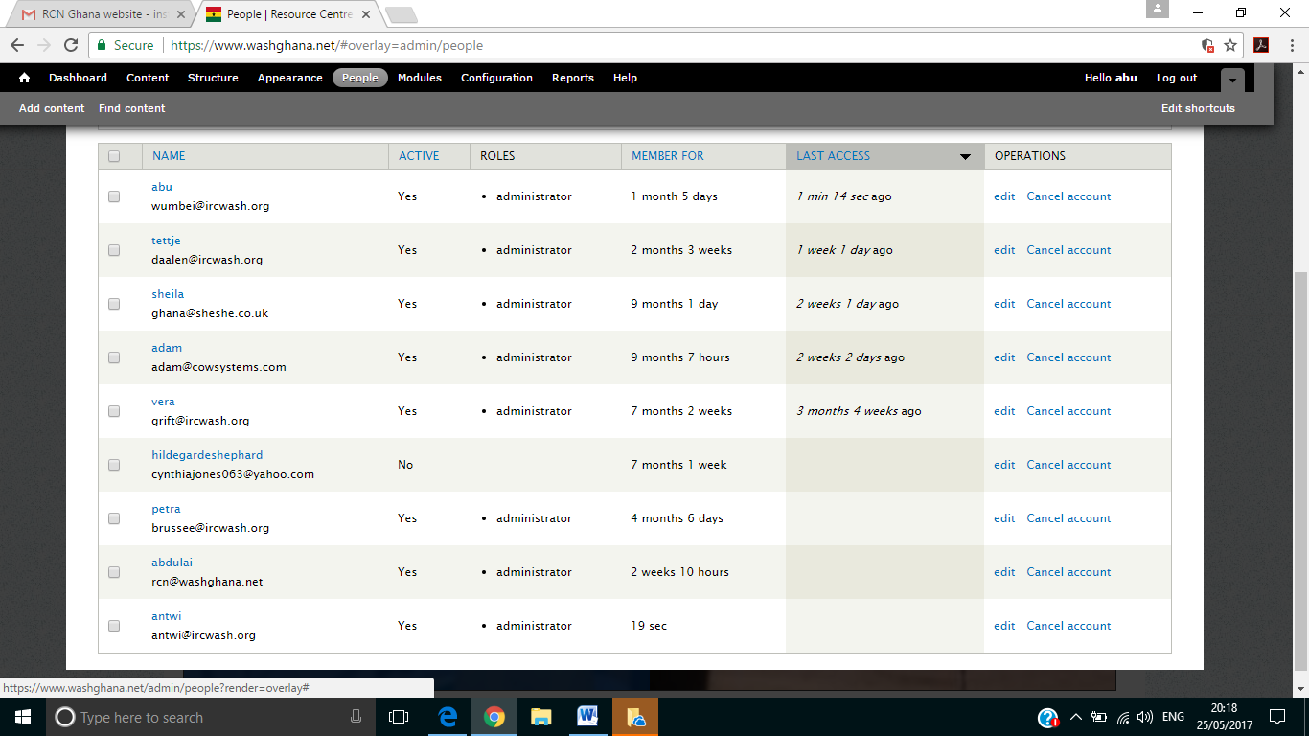

Logging in
If you have been assigned the administrator role – you are already a user and have received a username and a password. To log in to the system, follow the following steps.
- Go to https://www.washghana.net/
- Scroll down to the bottom of the page – here you see the section to login

- Fill in your ‘user name’ and your ‘password’ and click on ‘Log in’
You are now logged into the system and will be able to create and edit content.

Adding new ‘users’
If you want to grant new people access to the back-end of the website, they need to be added as ‘User’ to be able to upload content. Only the administrators of the website can add new users. These are steps to follow to add a new user:
- Make sure you yourself are logged in
- Click on ‘people’ in the top bar
- A new screen has appeared – here you click on ‘add user’
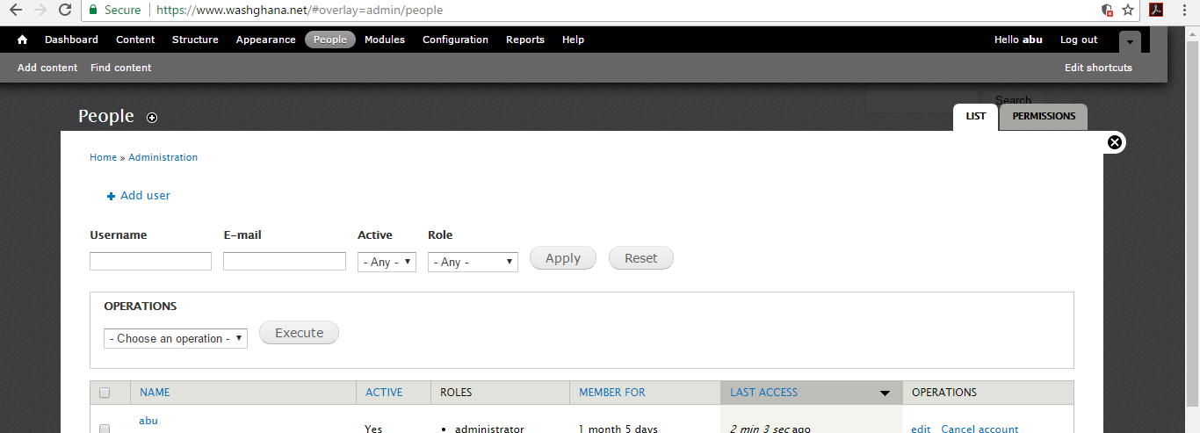
- Another screen has appeared. Here you must
  - assign the new user a new ‘username’
  - fill out the new users email address
  - provide the person with a (temporary) password (the user can change his / her password later as he likes
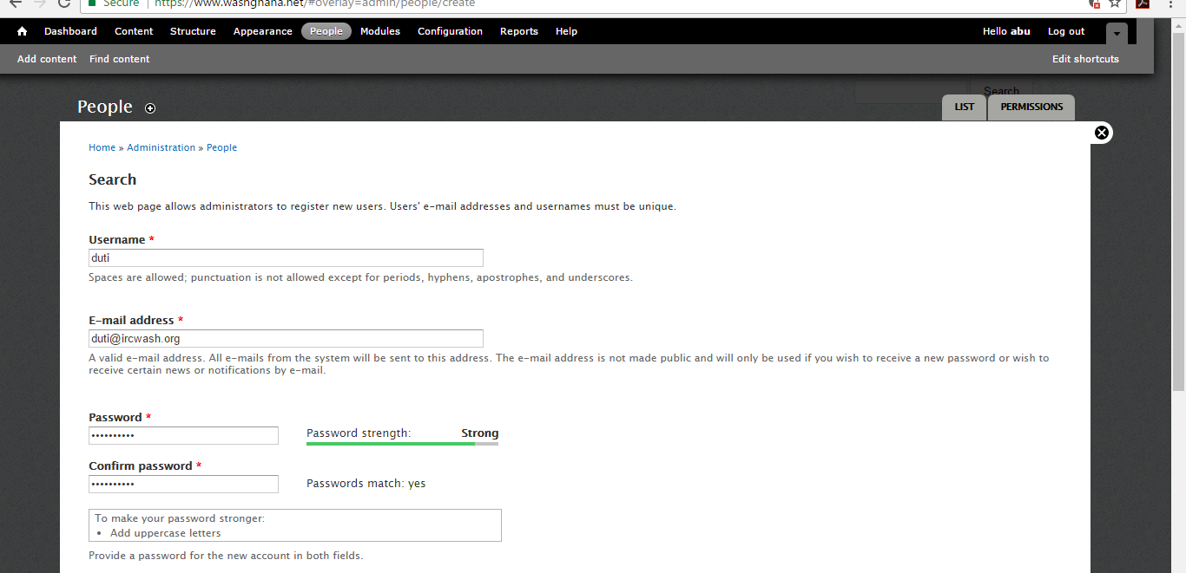
- Scroll down -here you decide
  - if the new user becomes an ‘authenticated user’ or also ‘administrator’
  - If you want to notify the new user of the new account
- Press ‘Create new account’ – so that account is confirmed
Now you know how to add a new user. However, we advise you to keep the number of users limited to protect the site and its contents.

Blocking users
If one of the administrators leaves RCN Ghana or IRC, make sure to follow-up by removing the persons ‘user’ rights. These are the steps to follow:
- Make sure you are on the ‘People’ page of the back-end
- Click on ‘cancel account’
- You get in a new window – here you can choose from a couple of options. For administrative reasons (as you might always want to know who was the ‘author’ of the content – we advise you opt for the first option. Make sure to confirm the cancellation of the account by clicking on ‘Cancel account’

Finding and adding content
Once you have been added as User and you can log in, you will see a black bar along the top of the site and a grey bar below that containing two options. ‘Find content’ and ‘Add content’.
Find content - lets you find content already on the system
Add content - is for creating new items.

Find content
When you select Find content you will find a long list of content that is already in the system.
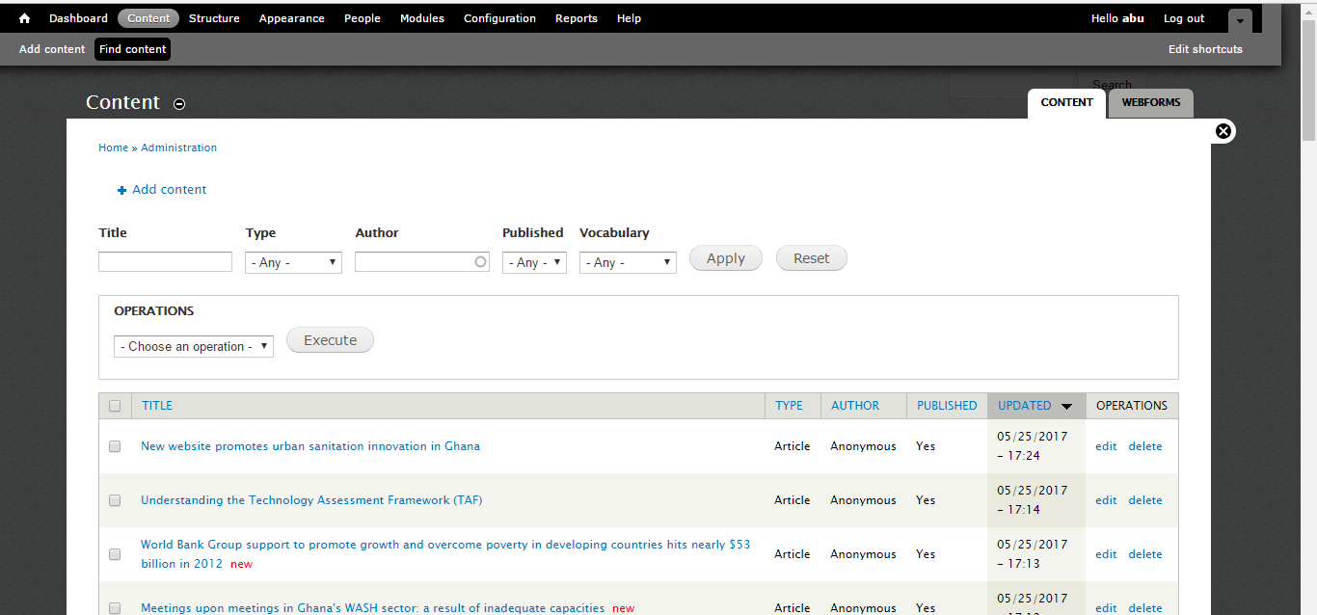

Filter content
There are several ways to filter the content that is already in the system and to find what you are looking for.
- Filter by at you are lookinmost of the times you are looking for the article that you just have worked on and is still in draft – you can find it by clicking on ooking fo.
- Title ndif you know the title of your article type it in the field and click on ‘apply’ it in the field and click on ‘applye typ article that
- Author – if you know the author of the article – type it in and click on ‘apply’ - all content from that author will be filtered.
- You can also filter by content ‘type’, by whether it is already ‘published’ (for content already published choose ‘Yes’ – for content which is not yet published / still in draft or unpublished choose ‘No’.
If you want to remove all filters you can click on ‘reset’

Add content
When you select Add content you find a list of content types to choose from. The list of content type options is limited and you will mostly use
- Article for news
- File for meeting minutes or meeting reports
- Biblio can best be used for ‘official documents’ as it contains fields with bibliographic information used in libraries.
- Folder is used as a container for storing items on one topic, for instance National Level Learning Alliance Platform (NLLAP) is a folder which contains all the meeting documents on this particular platform.

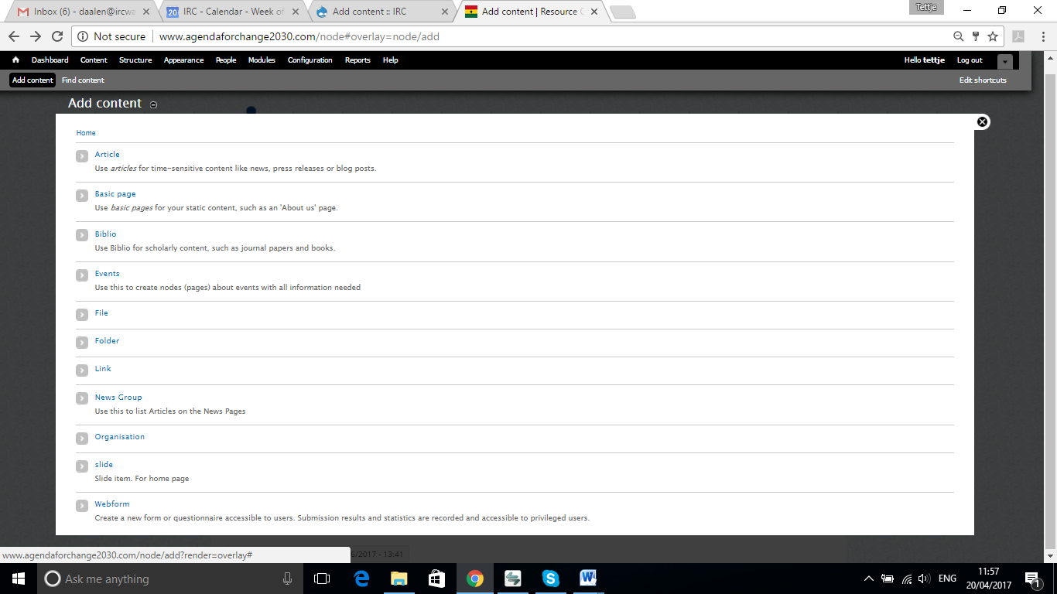

Add Article
Select Article from the list on page ‘Add content’ and fill in the following fields in the template – you get to the following screen
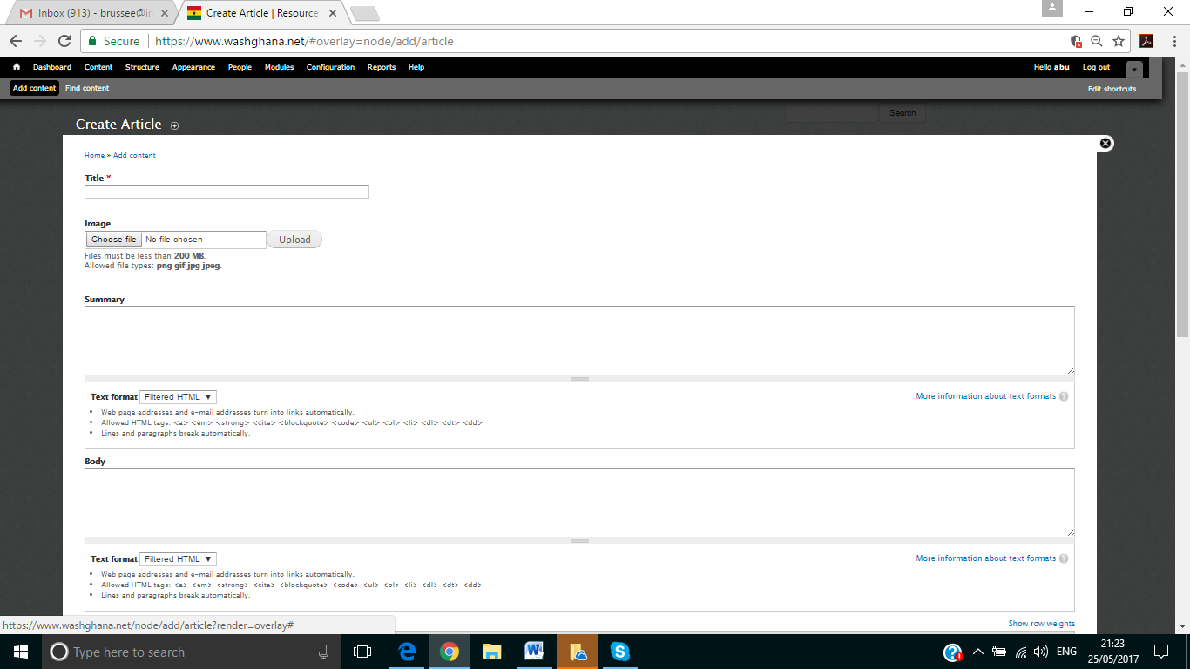

- Title: Add a title for your news piece.
Avoid jargon and acronyms. Even common ones like WASH are not understood by anyone not already working in the sector. If you must use jargon, you can explain it in the body of the content when you use it but avoid it in the summary and title.
Keep titles to 12 words or fewer for news.
- Image: you can add an image but is not necessary. But if you want to, here are the steps.
  - Click on ‘Choose file
  - Browse for an image on your computer
  - Select it
  - And click on ‘Open’
  - Do not forget to click on ‘Upload’
The picture is now being uploaded to the draft article. And a box appears next to the picture saying ‘alternate text’.

In this box you describe what can be seen on the picture – so that computers fit for visually impaired people – can read out what is on the image.
- Text. Once you are done with your image – you can almost start writing your article. First you have to make sure that the ‘text format’ is set to ‘Full HTML’ because then you can see the tool bar with all the icons which will help you format the text you want to insert.
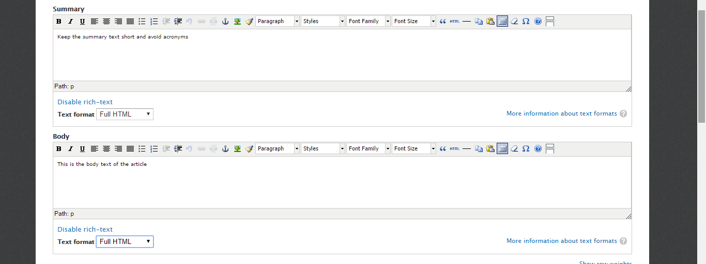
- First begin with the

Summary: This should be a short sentence introducing your article.
We recommend 12 words or fewer as a safe guide. Avoid links, formatting and images here. Above all, avoid jargon and acronyms as these will discourage people from reading your content.
Body: In the body area you will add the main content.
It is adviseable to prepare your article in a plain WORD document – and format it there. You can paste your text straight from WORD.
Some of the special features in the toolbar will be described below.

Formatting advice
Use of subheadings
Divide your text, by making use of subheadings. All subheadings should be marked up with Heading 2 from the pull down menu under ‘Format’. The smallest subheading is Heading 6.

Use of quotes
You can create one max. two featured quotes in the text by selecting the text and then pressing the blockquote icon (‘66’6speech marks)

Bullets or number
You can add bullets to a list or number it.

Tables
There is a table icon to help you create new tables.

Hyperlinks
You can add inline links by clicking on the knot/chain icon (see image below). Paste in the link and select Open link in New Window from the line Target.
If formatting is not working, it could be that there is hidden code in your text. Try copying the text into a notepad and then copying it back into the site and then adding the formatting again.

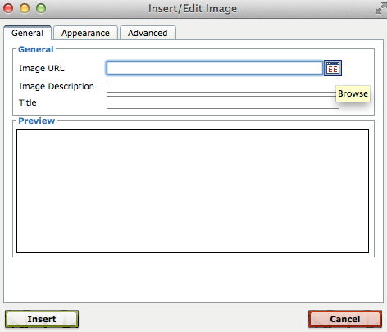
Images
If you want to add an image to your article. Go to the toolbar and select the picture icon -the icon looks like a green tree - .
A screen opens – and here you choose the button in the top right hand corner of the pop up screen.
You will now be able to select images already uploaded.
If the image you require is not already in the database, choose the second tab ‘Upload’ and add your image before returning to the browse screen to choose it.
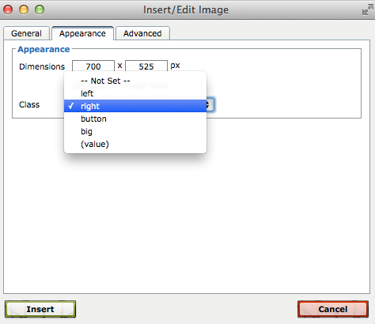
If you right click on the image in the browser window you can select whether you want it to fill the width of the screen, half the width or just a third.
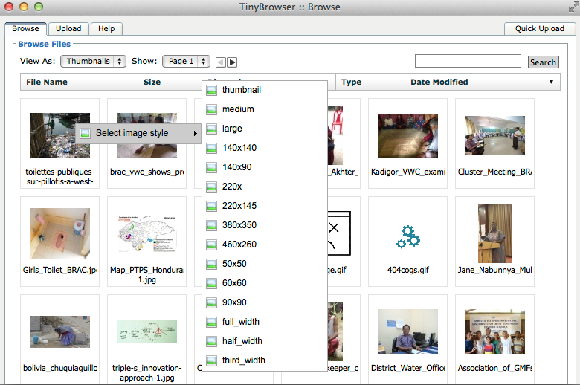
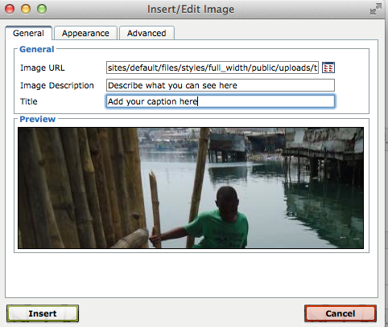
You will now be able to add a mandatory Image Description (or ‘Alt text’) which is essential for making the site accessible to visually impaired users and the Title which is an optional field that allows you to create a visible caption on your page under the image.
You can also choose whether the image aligns to the right (preferred) or to the left (for a bit of variety) by selecting the Appearance tab and from the class pull down select left or right. The text will now run around the image.
Click insert.
Note: on rare occasions it may be necessary to hyperlink an image itself. This can be done by selecting the image and then clicking the link (chain) icon. As these links can easily become out of date and get broken, it is best to avoid this and to use the External Links box described below.

Children
If you have an already uploaded item - either an ‘article’ a ‘file’, or a ‘biblio’ that is related to your article , you have the option to show this item below your news article . By typing in the title of your already uploaded item, you can attach it to the new article.

Publishing options
Way at the bottom is a field called ‘Publishing options’.
If you click this – a new screen opens.

Here you can untick the box Published if you do not want to publish your item yet. There is also an option to choose from if you want your item to show on the home page (promoted to home page).
DON’T PUT TOO MANY ITEMS ON THE HOME PAGE, SO REGULARLY REMOVE OLDER ITEMS.
There is also an option called Sticky at top of lists, but that should not be used. With this option you can manipulate the order of items, ensuring that the one you have ticked Sticky on top of lists that item will remain always at the top. Newer items will appear under it, so it is not helpful.

Embedding video or presentation
When adding a video or a presentation to the body of your content, you must first collect the ‘embed’ code from YouTube (where your video needs to be uploaded) or Slideshare (where your presentation needs to be uploaded). You will then select the last item on the editing bar (the one that looks like film). Ignore the first screen and choose the tab Source. Paste your code into here and click Insert. Your video or presentation will be visible when you save the page. Note sometimes you will need to refresh the saved page to see the embedded item.
What you don’t need to add: your name and the date will be added to the page automatically and if you have tagged it properly it should also appear in the right places on the site.
If you do not have a Slideshare account, you can make a PDF from your presentation and upload it as a File.

Add File
We use the content type ‘file’ for e.g. meeting minutes etc. documents in PDF – that you want to upload – without providing too much metadata (for that you would use the content type ‘biblio’).
‘Files’ can be displayed – underneath an article – and will look like a link.
How to add a file?
- Click on ‘Add content’ in the grey menu bar on top of the page
- Click on ‘File’
- Type the title of your file: keep it short-and straightforward, e.g. minutes_directorsmeeting_19082017
- Under ‘body’ you can add a two line explanation of the document.
- Under ‘file’ click on ‘choose file’ – you can now browse for the file on your computer – click ‘open’ and do not forget to click on ‘Upload’
- Scroll down – and click on ‘save’
You have now created a ‘File’ – but this file is not yet visible on the website.
It will only become visible – once you link the file to a news ‘article’ – when you add the ‘file’ under ‘children’ – see the section on ‘children’ under the chapter ‘Add article’.

Add Biblio

Add Folder

Add Event
Add

Add a Slide
Slides are the images in the carousels at the top of pages such as the homepage. [The process for setting up slides in pages is too complicated at the moment. I will ask the web developer to come up with a simpler process.]

